Name: Age of Exploration Packet
Station 1: Causes & Technology of Exploration
Watch the Tom Richey video to 5:04 (Stop at Dias) Fill in the information in the graphic organizer based on his lecture.
Ancient Routes | Nations Involved | Goods
Technology

Motivations | Portugal & Prince Henry

- Describe the general appearance of each of the ships. How many masts does each have? What shape are their sails? Which appears larger? Which appears wider? Which ship do you think could sail faster? Why?

- In addition to the cross-staff, what is helping the man in the image measure his latitude? Why was it important to be able to locate the Big Dipper?

- Why do you think this astrolabe was used so frequently if it was not accurate?

- What might have been the consequences of measuring latitude incorrectly? What if Columbus and his crew hadn’t measured latitude accurately on their second, third, or fourth voyages to the “New World”? What are the limitations to all of this navigational equipment?

- Why do you think something like this globe was valuable to the people in the 16th century? If you were a student during the 16th century, what might you have been able to learn from this globe?

- Looking at the maps you’ve been given, what do you notice about how they are drawn? Compare and contrast them. Based on your knowledge, what is accurate? Why do you think these maps are important?

- Imagine that you are a 16th-century European explorer planning an expedition to find new trade routes to Asia. Write a few sentences in which you describe some of the navigational instruments you’d use and how these instruments will help you find and record your way.

Station 2: European Exploration
Create a chart of the European Explorers & then complete the map that follows.
Explorer | Nation | Year | Significance
Bartholomew Dias
Vasco de Gama
Pedro Cabral
Christopher Columbus
Ponce de Leon
Amerigo Vespucci
Ferdinand Magellan
Hernan Cortez
Francisco Pizzaro

Hernando De Soto
Francisco Vázquez de Coronado
Henry Hudson
Jean Cabot
John Smith
Puritans
Samuel de Champlain
Rene-Robert Cavelier LaSalle
Giovanni da Verrazano

Read all directions before starting work.
Print all labels neatly.

You will need FIVE different colored pencils to complete your map.

- Label the following bodies of water:
Pacific Ocean, Indian Ocean, Hudson Bay, Gulf of Mexico, Caribbean Sea

- With one colored pencil, shade in Spain.

- With the same color as #2, trace the route of the following Spanish explorations. Label them.
Columbus, 1492; Balboa, 1513; Cortez, 1519; Ponce de Leon, 1513; Pizarro, 1532; Magellan, 1519; De Soto, 1539; Coronado, 1540

- With another colored pencil, shade in Portugal.

- With the same color as #4, trace the route of the following Portuguese explorations. Label them.
Dias, 1487 (pg 534); da Gama (pg 534), 1497; Cabral, 1500

- With another colored pencil, shade in England.

- With the same color as #6, trace the following routes of English exploration. Label them.
Hudson, 1610; Cabot, 1497; London Company (Smith), 1606; Mayflower, 1620

- With another colored pencil, shade in France.

- With the same color as #8, trace the following French explorations. Label them.
Verrazano, 1524; Cartier, 1534; La Salle, 1682;

- With another colored pencil, shade in The Netherlands (AKA Holland, Dutch).

- With the same color as #10, trace Hudson’s 1509 exploration and label it (note this is separate from Hudson’s expedition in #7).

- Draw and label the Line of Demarcation. To its left write Spain and to its right write Portugal.

- Create a key on the page to indicate the colors you used for each country.
Station 3: Columbia Exchange: As if you were writing an essay (don’t worry, you aren’t), create a thesis statement on the importance and/or impact of the Columbian Exchange. Then come up with at least five facts/details from the article to support your thesis. Then on the map that follows, cut and paste the images given to you on their correct movement across the Atlantic.

Thesis:

Supporting Details
1.
2.
3.
4.
5.
Others?
Station 4: Christopher Columbus
- How does Columbus describe the islands where he landed? How does he describe his interactions with the natives? What is the significance of the audience of the journal? How might this influence his writings?

- Look at the painting The Landing of Columbus. How does it depict the landing? How does this compare with Columbus’s journal? What biases may exist in this painting (again, who is the audience)?

- How does Loewen describe Columbus in his book? What evidence does he give? How does this compare with Columbus’s writings?

Crash Course Stations
Crash Course #21: 15th Century Mariners
Question |  | Choice 1 | Choice 2 | Choice 3
 | True or False: Columbus discovered America first | True | False
 | Indian Ocean trade was dominated by ___ merchants | Christian | Muslim | Jewish
 | China had a long history with Muslims especially when ruled | The Mongols | The Mongols | The Mongols
 | Between1405 to 1433 Zheng He led ____ voyages throughout the Indian Ocean | 7 | 14 | 28
 | Zheng He’s ships were ___ compared to Columbus’s | Smaller | Larger | the same size
 | What was China importing? (Kind of a trick question) | Porcelain | Prestige | Pottery
 | Vasco de Gama was from | Portugal | Spain | France
 | Prince Henry the Navigator was a patron of ___ | Musicians | Artists | Sailors
 | De Gama was the 1st who made it around Africa and into the | Atlantic Ocean | Indian Ocean | Pacific Ocean
 | What two things was de Gama looking for? (Two answers) | Knowledge | Gold | Christians
 | Columbus thought he’d made it to | China | Africa | East Indies
 | In 1494, Pope Alexander VI settled a dispute between Portugal and Spain by dividing the world with the | Treaty of San Domingo | Line of Demarcation | The Open Letter
 | For a time___ was the leading power in Europe | Portugal | England | Spain
 | After Columbus we can speak of the first time of a __ History | World | American | Asian

Question |  | Choice 1 | Choice 2 | Choice 3
 | What was the main culprit in killing off the Native Americans? | Brutality | Disease | Starvation
 | Most diseases came from the __ World | Old | New | Alien
 | The New World had one gift that was pretty destructive: | Cinnamon | Small Pox | Tobacco
 | European animals revolutionized the __ in America | Transportation | Trade | Food Supply
 | Before Europeans the largest beast of burden in America was | Llamas | Horses | Cows
 | Plains Indians went from agricultural to a __ lifestyle | Nomadic | Settled | Herders
 | New World plants led to a __ population in Europe | Decrease | Increase | Stagnant
 | 1½ acres of __ could feed an Irish family for a year | Tomato | Corn | Potato
 | Manioc cassava is so prevalent in __ many claim it’s native | Africa | Europe | Asia
 | The __ became known as the poor man’s staple in China | Corn | Rice | Sweet Potato
 | The transfer of people mostly went to | Europe | Africa | Americas
 | Africans mostly came to the New World as | Explorers | Slaves | Traders
 | Crosby argues that the Columbian Exchange was __ for Earth | Good | Bad | Beneficial
Crash Course #23: The Columbian Exchange

Crash Crouse #25: The Spanish Empire
Question |  | Choice 1 | Choice 2 | Choice 3
 | (T/F) The Aztecs were popular with the people they conquered | True | False | Neither
 | The Incan Empire was held together by | Slavery | Agriculture | Trade
 | The Spanish and the American Empires had a __ structure | Different | Similar
 | The main precious metal the Spanish found in South America was | Gold | Silver | Copper
 | The huge influx of silver caused skyrocketing | Deflation | Stagflation | Inflation
 | Charles gave Spain & the Americas to | Ferdinand I | Philip II | Charles III
 | He also inherited a rebellion in | England | Netherlands | Portugal
 | The English victory over the Spanish led to increased | Nationalism | Prosperity | Militarism
 | Most of the Silver went to Europe, but 1/3 of it went to | Africa | China | Americas
 | In the end, the silver trade____ the Spanish Empire | Weakened | Strengthened | Ended

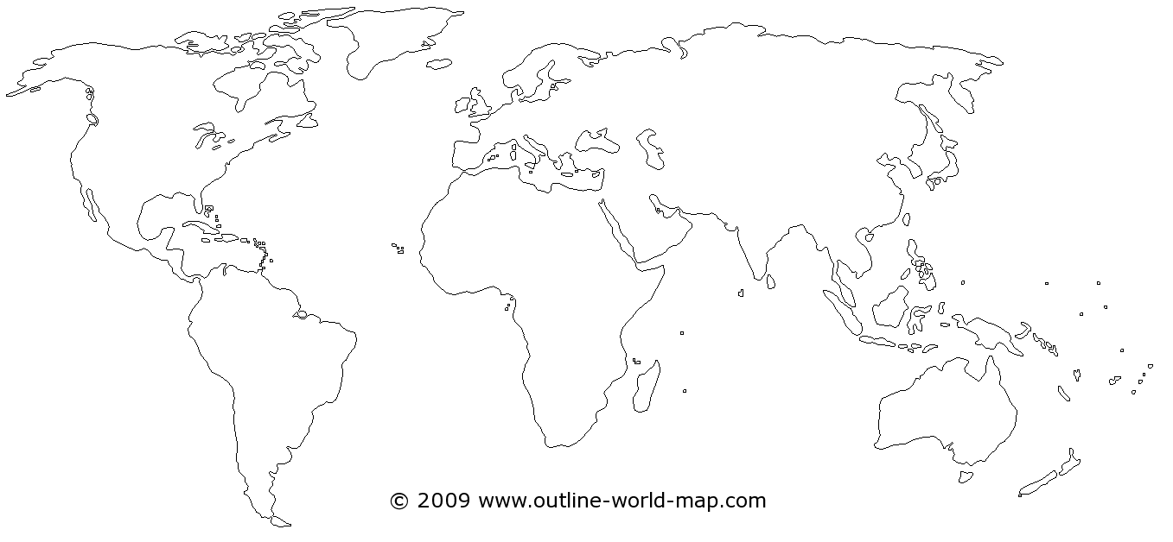
Columbian Exchange Map
Age of Exploration Map
Key
Spain
Portugal
England
France
The Netherlands

