Station 1:
Technology of the Age of Exploration
Introduction
Throughout the Age of Exploration, European navigators relied on the technology of their time to help them explore the seas. Developments in shipbuilding and navigational equipment enabled voyages of exploration to discover places they would not previously have been able to reach. The Portuguese caravel, for example, had features that made it particularly well suited for exploration. Caravels enabled Portuguese fleets to explore the African coast and made Portugal a leader among European nations in world exploration. They did not, however, allow for extremely long voyages such as Ferdinand Magellan’s circumnavigation of the world (which we will learn about later in this unit).

Ships
Portuguese Barca Portuguese Caravel
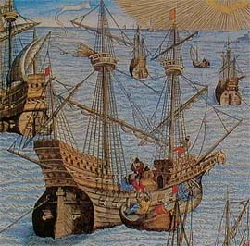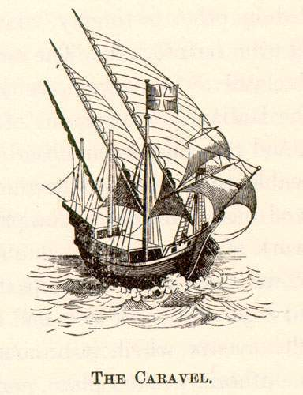

Navigation Methods
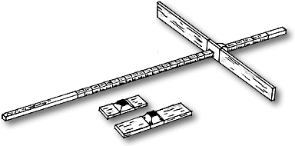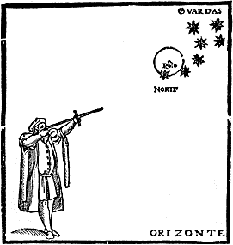
The cross-staff was used to measure latitude. The navigator would hold one end up to his eye and move the cross piece back and forth until its upper edge was aligned with the sun or the North Star and its lower edge was aligned with the horizon. He then noted where the cross piece lined up with the longer piece and looked at a table to convert this number into the latitude of the location where he was standing.

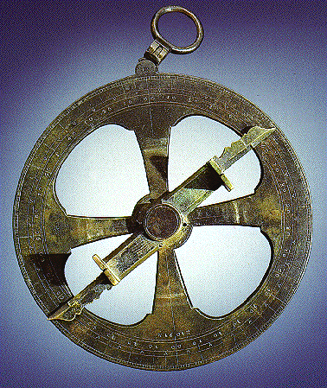
The astrolabe was another instrument used to measure latitude. The navigator hung it by the ring at the top of the alidade (the “hand”) to line up with the sun or a star. It was not particularly accurate but it was commonly used.

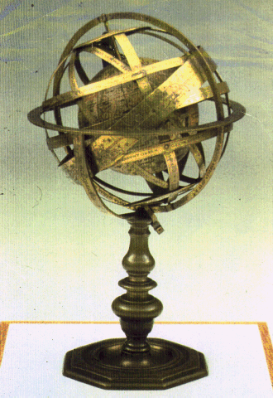
This globe was used to teach people of the 16th century how the world and celestial bodies looked and related to each other. It shows the Earth at the center of the solar system, with the planets, sun, moon, and several stars revolving around it. The brass strips around the globe represent the planets’ and sun’s movements around the Earth. It was created in 1543; the same year that Copernicus published his theory saying that the sun was actually the center of the solar system and that the Earth and other planets revolved around the sun.

Station 2:
European Explorers

Station 3: Columbian Exchange by J.R. McNeil
When Christopher Columbus and his crew arrived in the New World, two biologically distinct worlds were brought into contact. The animal, plant, and bacterial life of these two worlds began to mix in a process called the Columbian Exchange. The results of this exchange recast the biology of both regions and altered the history of the world.
Geologists believe that between 280 million and 225 million years ago, the earth’s previously separate land areas became welded into a landmass called Pangaea. About 120 million years ago, they believe, this landmass began to separate. As this happened, the Atlantic Ocean formed, dividing the Americas from Africa and Eurasia. Over the course of the next several million years in both the Americas and in Afro-Eurasia, biological evolution followed individual paths, creating two primarily separate biological worlds. However, when Christopher Columbus and his crew made land in the Bahamas in October 1492, these two long-separated worlds were reunited. Columbus’ voyage, along with the many voyages that followed, disrupted much of the biological segregation brought about by continental drift.
After Columbus’ arrival in the Americas, the animal, plant, and bacterial life of these two worlds began to mix. This process, first studied comprehensively by American historian Alfred Crosby, was called the Columbian Exchange. By reuniting formerly biologically distinct land masses, the Columbian Exchange had dramatic and lasting effects on the world. New diseases were introduced to American populations that had no prior experience of them. The results were devastating. These populations also were introduced to new weeds and pests, livestock, and pets. New food and fiber crops were introduced to Eurasia and Africa, improving diets and fomenting trade there. In addition, the Columbian Exchange vastly expanded the scope of production of some popular drugs, bringing the pleasures — and consequences — of coffee, sugar, and tobacco use to many millions of people. The results of this exchange recast the biology of both regions and altered the history of the world.

The flow from east to west: Disease
By far the most dramatic and devastating impact of the Columbian Exchange followed the introduction of new diseases into the Americas. When the first inhabitants of the Americas arrived across the Bering land bridge between 20,000 and 12,000 years ago, they brought few diseases with them. Why? For one reason, they had no domesticated animals, the original source of human diseases such as smallpox and measles. In addition, as they passed from Siberia to North America, the first Americans had spent many years in extreme cold, which eliminated many of the disease-causing agents that might have traveled with them. As a result, the first Americans and their descendants, perhaps 40 million to 60 million strong by 1492, enjoyed freedom from most of the infectious diseases that plagued populations in Afro-Eurasia for millennia. Meanwhile, in Asia and Africa, the domestication of herd animals brought new diseases spread by cattle, sheep, pigs, and fowl.
Soon after 1492, sailors inadvertently introduced these diseases — including smallpox, measles, mumps, whooping cough, influenza, chicken pox, and typhus — to the Americas. People who lived in Afro-Eurasia had developed some immunities to these diseases because they had long existed among most Afro-Eurasian populations. However, the Native Americans had no such immunities. Adults and children alike were stricken by wave after wave of epidemic, which produced catastrophic mortality throughout the Americas. In the larger centers of highland Mexico and Peru, many millions of people died. On some Caribbean islands, the Native American population died out completely. In all, between 1492 and 1650, perhaps 90 percent of the first Americans had died.
This loss is considered among the largest demographic disasters in human history. By stripping the Americas of much of the human population, the Columbian Exchange rocked the region’s ecological and economic balance. Ecosystems were in tumult as forests regrew and previously hunted animals increased in number. Economically, the population decrease brought by the Columbian Exchange indirectly caused a drastic labor shortage throughout the Americas, which eventually contributed to the establishment of African slavery on a vast scale in the Americas. By 1650, the slave trade had brought new diseases, such as malaria and yellow fever, which further plagued Native Americans.

The flow from east to west: Crops and animals
Eurasians sent much more than disease westward. The introduction of new crops and domesticated animals to the Americas did almost as much to upset the region’s biological, economic, and social balance as the introduction of disease had. Columbus had wanted to establish new fields of plenty in the Americas. On his later voyages he brought many crops he hoped might flourish there. He and his followers brought the familiar food grains of Europe: wheat, barley, and rye. They also brought Mediterranean plantation crops such as sugar, bananas, and citrus fruits, which all had originated in South or Southeast Asia. At first, many of these crops fared poorly; but eventually they all flourished. After 1640, sugar became the mainstay of the Caribbean and Brazilian economies, becoming the foundation for some of the largest slave societies ever known. The production of rice and cotton, both imported in the Columbian Exchange, together with tobacco, formed the basis of slave society in the United States. Wheat, which thrived in the temperate latitudes of North and South America and in the highlands of Mexico, eventually became a fundamental food crop for tens of millions of people in the Americas. Indeed, by the late 20th century, wheat exports from Canada, the United States, and Argentina were feeding millions of people outside the Americas. It is true that the spread of these crops drastically changed the economy of the Americas. However, these new crops supported the European settler societies and their African slave systems. The Native Americans preferred their own foods.
When it came to animals, however, the Native Americans borrowed eagerly from the Eurasian stables. The Columbian Exchange brought horses, cattle, sheep, goats, pigs, and a collection of other useful species to the Americas. Before Columbus, Native American societies in the high Andes had domesticated llamas and alpacas, but no other animals weighing more than 45 kg (100 lbs). And for good reason: none of the other 23 large mammal species present in the Americas before the arrival of Columbus were suitable for domestication. In contrast, Eurasia had 72 large animal species, of which 13 were suitable for domestication. So, while Native Americans had plenty of good food crops available before 1492, they had few domesticated animals. The main ones, aside from llamas and alpacas, were dogs, turkeys, and guinea pigs.
Of all the animals introduced by the Europeans, the horse held particular attraction. Native Americans first encountered it as a fearsome war beast ridden by Spanish conquistadors. However, they soon learned to ride and raise horses themselves. In the North American great plains, the arrival of the horse revolutionized Native American life, permitting tribes to hunt the buffalo far more effectively. Several Native American groups left farming to become buffalo-hunting nomads and, incidentally, the most formidable enemies of European expansion in the Americas.
Cattle, sheep, pigs, and goats also proved popular in the Americas. Within 100 years after Columbus, huge herds of wild cattle roamed many of the natural grasslands of the Americas. Wild cattle, and, to a lesser degree, sheep and goats, menaced the food crops of Native Americans, notably in Mexico. Eventually ranching economies emerged, based variously on cattle, goats, or sheep. The largest ranches emerged in the grasslands of Venezuela and Argentina, and on the broad sea of grass that stretched from northern Mexico to the Canadian prairies. Native Americans used the livestock for meat, tallow, hides, transportation, and hauling. Altogether, the suite of domesticated animals from Eurasia brought a biological, economic, and social revolution to the Americas.

The flow from west to east: Disease
In terms of diseases, the Columbian Exchange was a wildly unequal affair, and the Americas got the worst of it. The flow of disease from the Americas eastward into Eurasia and Africa was either trivial or consisted of a single important infection. Much less is known about pre-Columbian diseases in the Americas than what is known about those in Eurasia. Based on their study of skeletal remains, anthropologists believe that Native Americans certainly suffered from arthritis. They also had another disease, probably a form of tuberculosis that may or may not have been similar to the pulmonary tuberculosis common in the modern world. Native Americans also apparently suffered from a group of illnesses that included two forms of syphilis. One controversial theory asserts that the venereal syphilis epidemic that swept much of Europe beginning in 1494 came from the Americas; however, the available evidence remains inconclusive.

The flow from west to east: Crops and cuisine
America’s vast contribution to Afro-Eurasia in terms of new plant species and cuisine, however, transformed life in places as far apart as Ireland, South Africa, and China. Before Columbus, the Americas had plenty of domesticated plants. By the time Columbus had arrived, dozens of plants were in regular use, the most important of which were maize (corn), potatoes, cassava, and various beans and squashes. Lesser crops included sweet potato, papaya, pineapple, tomato, avocado, guava, peanuts, chili peppers, and cacao, the raw form of cocoa. Within 20 years of Columbus’ last voyage, maize had established itself in North Africa and perhaps in Spain. It spread to Egypt, where it became a staple in the Nile Delta, and from there to the Ottoman Empire, especially the Balkans. By 1800, maize was the major grain in large parts of what is now Romania and Serbia, and was also important in Hungary, Ukraine, Italy, and southern France. It was often used as animal feed, but people ate it too, usually in a porridge or bread. Maize appeared in China in the 16th century and eventually supplied about one-tenth of the grain supply there. In the 19th century it became an important crop in India. Maize probably played its greatest role, however, in southern Africa. There maize arrived in the 16th century in the context of the slave trade. Southern African environmental conditions, across what is now Angola, Zambia, Zimbabwe, Mozambique, and eastern South Africa, suited maize handsomely. Over the centuries, maize became the primary peasant food in much of southern Africa. In late 20th-century South Africa, for example, maize grew in two-thirds to three-quarters of the region’s cropland.
Despite maize’s success, the humble potato probably had a stronger impact in improving the food supply and in promoting population growth in Eurasia. The potato had little impact in Africa, where conditions did not suit it. But in northern Europe the potato thrived. It had the most significant effect on Ireland, where it promoted a rapid population increase until a potato blight ravaged the crop in 1845, bringing widespread famine to the area. After 1750, Scandinavia, the Low Countries, Germany, Poland, and Russia also gradually accepted the potato, which helped drive a general population explosion in Europe. This population explosion may have laid the foundation for world-shaking developments such as the Industrial Revolution and modern European imperialism. The potato also fed mountain populations around the world, notably in China, where it encouraged settlement of mountainous regions.
While maize and potatoes had the greatest world historical importance of the American crops, lesser crops made their marks as well. In West Africa, peanuts and cassava provided new foodstuffs. Cassava, a tropical shrub native to Brazil, has starchy roots that will grow in almost any soil. In the leached soils of West and Central Africa, cassava became an indispensable crop. Today some 200 million Africans rely on it as their main source of nutrition. Cacao and rubber, two other South American crops, became important export items in West Africa in the 20th century. The sweet potato, which was introduced into China in the 1560s, became China’s third most important crop after rice and wheat. It proved a useful supplement to diets throughout the monsoon lands of Asia. Indeed, almost everywhere in the world, one or another American food crops caught on, complementing existing crops or, more rarely, replacing them. By the late 20th century, about one-third of the world’s food supply came from plants first cultivated in the Americas. The modern rise of population surely would have been slower without them.
In contrast, the animals of the Americas have had very little impact on the rest of the world, unless one considers its earliest migrants. The camel and the horse actually originated in North America and migrated westward across the Bering land bridge to Asia, where they evolved into the forms familiar today. By the time of the Columbian Exchange, these animals were long extinct in the Americas, and the majority of America’s domesticated animals would have little more than a tiny impact on Afro-Eurasia. One domesticated animal that did have an effect was the turkey. Wild animals of the Americas have done only a little better. Probably after the 19th century, North American muskrats and squirrels successfully colonized large areas of Europe. Deliberate introductions of American animals, such as raccoons fancied for their fur and imported to Germany in the 1920s, occasionally led to escapes and the establishment of feral animal communities. However, no species introduced from the Americas revolutionized human affairs or animal ecology anywhere in Afro-Eurasia. In terms of animal populations as with disease, the Americas contributed little that could flourish in the conditions of Europe, Africa, or Asia.

The Columbian Exchange in the modern world
As the late dates of the introduction of muskrats and raccoons to Europe suggest, the Columbian Exchange continues into the present. Indeed, it will surely continue into the future as modern transportation continues the pattern begun by Columbus. Recently, for example, zebra mussels from the Black Sea, stowed away in the ballast water of ships, invaded North American waters. There they blocked the water intakes of factories, nuclear power plants, and municipal filtration plants throughout the Great Lakes region. Just as the arrival of Christopher Columbus’s ships in America in the 15th century resulted in the worldwide exchange of disease, crops, and animals, the 20th-century practice of ships using water as ballast helped unite the formerly diverse flora and fauna of the world’s harbors and estuaries. Similarly, air transport allows the spread of insects and diseases that would not easily survive longer, slower trips. Modern transport carries on in the tradition of Columbus by promoting a homogenization of the world’s plants and animals. To date, however, the world historical importance of modern exchanges pales beside that which took place in the original Columbian Exchange.

Crops  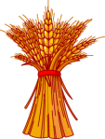  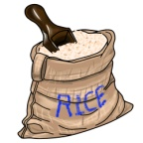 | Animals  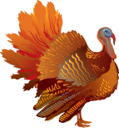  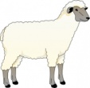  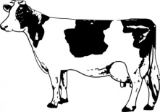  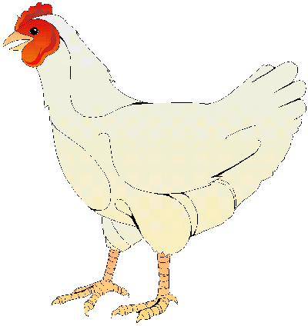  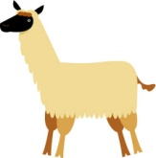  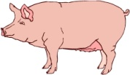  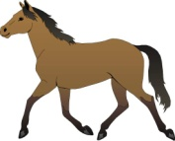  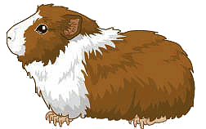 | 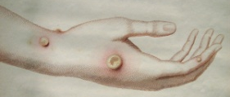  Diseases  Influenza  Small Pox

Crops | Animals | Diseases  Influenza  Small Pox

Station 4:
The Controversy of Christopher Columbus

EXCERPT FROM: “The Journal of Christopher Columbus”

NOTE BEFORE READING: Columbus kept a ship’s log, or journal, of his first voyage from Spain to the Americas. When he returned to Spain in 1493, he presented the journal to King Ferdinand and Queen Isabella, who funded the journey. This version originally copied by the missionary Bartolomé de Las Casas; while printing presses were invented by this time, there were obviously none in the America. In the first part of this text, “October 11,”the text refers to Columbus in the third person as “admiral.” Later in the excerpt, the text comes directly from Columbus’s words as they were written in the journal. Consider as you read, the thoughts and feelings of both the Indigenous people, as well as the Europeans. What does Columbus state are his aims in coming to this “green that it is a pleasure to gaze upon it?”

October 11th. . .

Two hours after midnight land appeared, at a distance of about two leagues from them. They took in all sail, remaining with the mainsail, which is the great sail without bonnets, and kept jogging, waiting for day, a Friday, on which they reached a small island of the Lucayos, which is called in the language of the Indians “Guanahaní.” Immediately they saw naked people, and the admiral went ashore in the armed boat, and Martin Alonso Pinzón and Vicente Yañez, his brother, who was captain of the Ninã.

The admiral brought out the royal standard, and the captains went with two banners of the Green Cross, which the admiral flew on all the ships as a flag with an F [for Ferdinand] and a Y [for Isabella], and over each letter their crown, one being on one side of the [cross] and the other on the other.

When they had landed, they saw very green trees and much water and fruit of various kinds. The admiral called the two captains and the others who had landed, and Rodrigo de Escobedo, secretary of the whole fleet, and Rodrigo Sanchez de Segovia, and said that they should bear witness and testimony how he, before them all, took possession of the island, as in fact he did, for the King and Queen, his Sovereigns, making the declarations which are required, as is contained more at length in the testimonies which were there made in writing. Soon many people of the island gathered there. What follows are the actual words of the admiral, in his book of his first voyage and discovery of these Indies.

“I,” he says, “in order that they might feel great amity towards us, because I knew that they were a people to be delivered and converted to our holy faith rather by love than by force, gave to some among them some red caps and some glass beads, which they hung round their necks, and many other things of little value. At this they were greatly pleased and became so entirely our friends that it was a wonder to see.

Afterwards they came swimming to the ships’ boats, where we were, and brought us parrots and cotton thread in balls, and spears and many other things, and we exchanged for them other things, such as small glass beads and hawks’ bells, which we gave to them. In fact, they took all and gave all, such as they had, with good will, but it seemed to me that they were a people very deficient in everything. They all go naked as their mother bore them, and the women also, although I saw only one very young girl. And all those whom I did see were youths, so that I did not see one who was over thirty years of age; they were very well built, with very handsome bodies and very good faces. Their hair is coarse almost like the hairs of a horse’s tail and short; they wear their hair down over their eyebrows, except for a few strands behind, which they wear long and never cut.

Some of them are painted black, and they are the colour of the people of the Canaries, neither black nor white, and some of them are painted white and some red and some in any colour that they find. Some of them paint their faces, some their whole bodies, some only the eyes, and some only the nose. They do not bear arms or know them, for I showed to them swords and they took them by the blade and cut themselves through ignorance. They have no iron.

Their spears are certain reeds, without iron, and some of these have a fish tooth at the end, while others are pointed in various ways. They are all generally fairly tall, good looking and well proportioned.

I saw some who bore marks of wounds on their bodies, and I made signs to them to ask how this came about, and they indicated to me that people came from other islands, which are near, and wished to capture them, and they defended themselves. And I believed and still believe that they come here from the mainland to take them for slaves. They should be good servants and of quick intelligence, since I see that they very soon say all that is said to them, and I believe that they would easily be made Christians, for it appeared to me that they had no creed. Our Lord willing, at the time of my departure I will bring back six of them to Your Highnesses, that they may learn to talk. I saw no beast of any kind in this island, except parrots.” All these are the words of the admiral.

Saturday, October 13th...

As soon as day broke, there came to the shore many of these men, all youths, as I have said, and all of a good height, very handsome people. Their hair is not curly, but loose and coarse as the hair of a horse; all have very broad foreheads and heads, more so than has any people that I have seen up to now. Their eyes are very lovely and not small. They are not at all black, but the colour of Canarians [an island off the coast of Africa, also controlled by Europe], and nothing else could be expected, since this is in one line from east to west with the island of Hierro in the Canaries. Their legs are very straight, all alike; they have no bellies but very good figures.

They came to the ship in boats, which are made of a tree trunk like long boat and all of one piece. They are very wonderfully carved, considering the country, and large, so that in some forty or forty-five men came. Others are smaller, so that in some only a solitary man came. They row them with a paddle, like a baker’s peel, and they travel wonderfully fast. If one capsizes, all at once begin to swim and right it, baling it out with gourds which they carry with them. They brought balls of spun cotton and parrots and spears and other trifles, which it would be tedious to write down, and they gave all for anything that was given to them.

And I was attentive and labored to know if they had gold, and I saw that some of them wore a small piece hanging from a hole which they have in the nose, and from signs I was able to understand that, going to the south or going round the island to the south, there was a king who had large vessels of it and possessed much gold. I endeavored to make them go there, and afterwards saw that they were not inclined for the journey. I resolved to wait until the afternoon of the following day, and after that to leave for the south-west, for, as many of them indicated to me, they said that there was land to the south and to the south-west and to the north-west, and that those of the north-west often came to attack them. So I resolved to go to the south-west, to seek the gold and precious stones.

This island is fairly large and very flat; the trees are very green and there is much water.

In the center of it, there is a very large lake; there is no mountain, and all is so green that it is a pleasure to gaze upon it. The people also are very gentle and, since they long to possess something of ours and fear that nothing will be given to them unless they give something, when they have nothing, they take what they can and immediately throw themselves into the water and swim. But all that they do possess, they give for anything which is given to them, so that they exchange things even for pieces of broken dishes and bits of broken glass cups. . . .

With fifty men we could subjugate them all and make them do whatever we want.

Hero-making, Christopher Columbus

Lies My Teacher Told Me: Everything Your American History Textbook Got Wrong

by James W. Loewen excerpted from the book
James Baldwin: What passes for identity in America is a series of myths about one's heroic ancestors.
W E B Du Bois: [American] history ... paints perfect men and noble nations, but it does not tell the truth.
Bartolome de las Casas: What we committed in the Indies stands out among the most unpardonable offenses ever committed against God and mankind and this trade [in Indian slaves] as one of the most unjust, evil, and cruel among them.
_________________

Christopher Columbus introduced two phenomena that revolutionized race relations and transformed the modern world: the taking of land, wealth, and labor from indigenous peoples, leading to their near extermination, and the transatlantic slave trade, which created a racial underclass.
Columbus's initial impression of the Arawaks, who inhabited most of the islands in the Caribbean, was quite favorable. He wrote in his journal on October 13, 1492: "At daybreak great multitudes of men came to the shore, all young and of fine shapes, and very handsome. Their hair was not curly but loose and coarse like horse-hair. All have foreheads much broader than any people I had hitherto seen. Their eyes are large and very beautiful. They are not black, but the color of the inhabitants of the Canaries." (This reference to the Canaries was ominous, for Spain was then in the process of exterminating the aboriginal people of those islands.) Columbus went on to describe the Arawaks' canoes, "some large enough to contain 40 or 45 men." Finally, he got down to business: "I was very attentive to them, and strove to learn if they had any gold. Seeing some of them with little bits of metal hanging at their noses, I gathered from them by signs that by going southward or steering round the island in that direction, there would be found a king who possessed great cups full of gold." At dawn the next day, Columbus sailed to the other side of the island, probably one of the Bahamas, and saw two or three villages. He ended his description of them with these menacing words: "I could conquer the whole of them with fifty men and govern them as I pleased."
On his first voyage, Columbus kidnapped some ten to twenty-five Indians and took them back with him to Spain. Only seven or eight of the Indians arrived alive, but along with the parrots, gold trinkets, and other exotica, they caused quite a stir in Seville. Ferdinand and Isabella provided Columbus with seventeen ships, 1,200 to 1,500 men, cannons, crossbows, guns, cavalry, and attack dogs for a second voyage.
One way to visualize what happened next is with the help of the famous science fiction story War of the Worlds. H. G. Wells intended his tale of earthlings' encounter with technologically advanced aliens as an allegory. His frightened British commoners (New Jerseyites in Orson Welles's radio adaptation) were analogous to the "primitive" peoples of the Canaries or America, and his terrifying aliens represented the technologically advanced Europeans. As we identify with the helpless earthlings, Wells wanted us also to sympathize with the natives on Haiti in 1493, or on Australia in 1788, or in the upper Amazon jungle in the 1990s.
When Columbus and his men returned to Haiti in 1493, they demanded food, gold, spun cotton-whatever the Indians had that they wanted, including sex with their women. To ensure cooperation, Columbus used punishment by example. When an Indian committed even a minor offense, the Spanish cut off his ears or nose. Disfigured, the person was sent back to his village as living evidence of the brutality the Spaniards were capable of.
After a while, the Indians had had enough. At first their resistance was mostly passive. They refused to plant food for the Spanish to take. They abandoned towns near the Spanish settlements. Finally, the Arawaks fought back. Their sticks and stones were no more effective against the armed and clothed Spanish, however, than the earthlings' rifles against the aliens' death rays in War of the Worlds.
The attempts at resistance gave Columbus an excuse to make war. On March 24, 1495, he set out to conquer the Arawaks. Bartolome de Las Casas described the force Columbus assembled to put down the rebellion. "Since the Admiral perceived that daily the people of the land were taking up arms, ridiculous weapons in reality . . . he hastened to proceed to the country and disperse and subdue, by force of arms, the people of the entire island . . . For this he chose 200 foot soldiers and 20 cavalry, with many crossbows and small cannon, lances, and swords, and a still more terrible weapon against the Indians, in addition to the horses: this was 20 hunting dogs, who were turned loose and immediately tore the Indians apart." Naturally, the Spanish won. According to Kirkpatrick Sale, who quotes Ferdinand Columbus's biography of his father: "The soldiers mowed down dozens with point-blank volleys, loosed the dogs to rip open limbs and bellies, chased fleeing Indians into the bush to skewer them on sword and pike, and 'with God's aid soon gained a complete victory, killing many Indians and capturing others who were also killed.' "
Having as yet found no fields of gold, Columbus had to return some kind of dividend to Spain. In 1495 the Spanish on Haiti initiated a great slave raid. They rounded up 1,500 Arawaks, then selected the 500 best specimens (of whom 200 would die en route to Spain). Another 500 were chosen as slaves for the Spaniards staying on the island. The rest were released. A Spanish eyewitness described the event: "Among them were many women who had infants at the breast. They, in order the better to escape us, since they were afraid we would turn to catch them again, left their infants anywhere on the ground and started to flee like desperate people; and some fled so far that they were removed from our settlement of Isabela seven or eight days beyond mountains and across huge rivers; wherefore from now on scarcely any will be had." Columbus was excited. "In the name of the Holy Trinity, we can send from here all the slaves and brazil-wood which could be sold," he wrote to Ferdinand and Isabella in 1496. "In Castile, Portugal, Aragon,.. . and the Canary Islands they need many slaves, and I do not think they get enough from Guinea." He viewed the Indian death rate optimistically: "Although they die now, they will not always die. The Negroes and Canary Islanders died at first."
In the words of Hans Koning, "There now began a reign of terror in Hispaniola." Spaniards hunted Indians for sport and murdered them for dog food. Columbus, upset because he could not locate the gold he was certain was on the island, set up a tribute system. Ferdinand Columbus described how it worked: "[The Indians] all promised to pay tribute to the Catholic Sovereigns every three months, as follows: In the Cibao, where the gold mines were, every person of 14 years of age or upward was to pay a large hawk's bell of gold dust; all others were each to pay 25 pounds of cotton. Whenever an Indian delivered his tribute, he was to receive a brass or copper token which he must wear about his neck as proof that he had made his payment. Any Indian found without such a token was to be punished." With a fresh token, an Indian was safe for three months, much of which time would be devoted to collecting more gold. Columbus's son neglected to mention how the Spanish punished those whose tokens had expired: they cut off their hands.
All of these gruesome facts are available in primary source material- letters by Columbus and by other members of his expeditions-and in the work of Las Casas, the first great historian of the Americas, who relied on primary materials and helped preserve them. I have quoted a few primary sources in this chapter. Most textbooks make no use of primary sources. A few incorporate brief extracts that have been carefully selected or edited to reveal nothing unseemly about the Great Navigator.
The tribute system eventually broke down because what it demanded was impossible. To replace it, Columbus installed the encomienda system, in which he granted or "commended" entire Indian villages to individual colonists or groups of colonists. Since it was not called slavery, this forced-labor system escaped the moral censure that slavery received. Following Columbus's example, Spain made the encomienda system official policy on Haiti in 1502; other conquistadors subsequently introduced it to Mexico, Peru, and Florida.
The tribute and encomienda systems caused incredible depopulation. On Haiti the colonists made the Indians mine gold for them, raise Spanish food, and even carry them everywhere they went. The Indians couldn't stand it. Pedro de Cordoba wrote in a letter to King Ferdinand in 1517, "As a result of the sufferings and hard labor they endured, the Indians choose and have chosen suicide. Occasionally a hundred have committed mass suicide. The women, exhausted by labor, have shunned conception and childbirth . . . Many, when pregnant, have taken something to abort and have aborted. Others after delivery have killed their children with their own hands, so as not to leave them in such oppressive slavery."
Beyond acts of individual cruelty, the Spanish disrupted the Indian ecosystem and culture. Forcing Indians to work in mines rather than in their gardens led to widespread malnutrition. The intrusion of rabbits and livestock caused further ecological disaster. Diseases new to the Indians played a role, although smallpox, usually the big killer, did not appear on the island until after 1516. Some of the Indians tried fleeing to Cuba, but the Spanish soon followed them there. Estimates of Haiti's pre-Columbian population range as high as 8,000,000 people. When Christopher Columbus returned to Spain, he left his brother Bartholomew in charge of the island. Bartholomew took a census of Indian adults in 1496 and came up with 1,100,000. The Spanish did not count children under fourteen and could not count Arawaks who had escaped into the mountains. Kirkpatrick Sale estimates that a more accurate total would probably be in the neighborhood of 3,000,000. "By 1516," according to Benjamin Keen, "thanks to the sinister Indian slave trade and labor policies initiated by Columbus, only some 12,000 remained." Las Casas tells us that fewer than 200 Indians were alive in 1542. By 1555, they were all gone.
Thus nasty details like cutting off hands have somewhat greater historical importance than nice touches like "Tierra!" Haiti under the Spanish is one of the primary instances of genocide in all human history. Yet only one of the twelve textbooks, The American Pageant, mentions the extermination. None mentions Columbus's role in it.
Columbus not only sent the first slaves across the Atlantic, he probably sent more slaves-about five thousand-than any other individual. To her credit, Queen Isabella opposed outright enslavement and returned some Indians to the Caribbean. But other nations rushed to emulate Columbus. In 1501 the Portuguese began to depopulate Labrador, transporting the now extinct Beothuk Indians to Europe and Cape Verde as slaves. After the British established beachheads on the Atlantic coast of North America, they encouraged coastal Indian tribes to capture and sell members of more distant tribes. Charleston, South Carolina, became a major port for exporting Indian slaves. The Pilgrims and Puritans sold the survivors of the Pequot War into slavery in Bermuda in 1637. The French shipped virtually the entire Natchez nation in chains to the West Indies in 1731
A particularly repellent aspect of the slave trade was sexual. As soon as the 1493 expedition got to the Caribbean, before it even reached Haiti, Columbus was rewarding his lieutenants with native women to rape. On Haiti, sex slaves were one more perquisite that the Spaniards enjoyed. Columbus wrote a friend in 1500, "A hundred castellanoes are as easily obtained for a woman as for a farm, and it is very general and there are plenty of dealers who go about looking for girls; those from nine to ten are now in demand."
The slave trade destroyed whole Indian nations. Enslaved Indians died. To replace the dying Haitians, the Spanish imported tens of thousands more Indians from the Bahamas, which "are now deserted," in the words of the Spanish historian Peter Martyr, reporting in 1516. Packed in below deck, with hatchways closed to prevent their escape, so many slaves died on the trip that "a ship without a compass, chart, or guide, but only following the trail of dead Indians who had been thrown from the ships could find its way from the Bahamas to Hispaniola." Puerto Rico and Cuba were next.
Because the Indians died, Indian slavery then led to the massive slave trade the other way across the Atlantic, from Africa. This trade also began on Haiti, initiated by Columbus's son in 1505. Predictably, Haiti then became the site of the first large-scale slave revolt, when blacks and Indians banded together in 1519. The uprising lasted more than a decade and was finally brought to an end by the Spanish in the 1530s.
Of the twelve textbooks, only six mention that the Spanish enslaved or exploited the Indians anywhere in the Americas. Of these only four verge on mentioning that Columbus was involved. The United States- A History of the Republic places the following passage about the fate of the Indians under the heading "The Fate of Columbus": "Some Spaniards who had come to the Americas had begun to enslave and kill the original Americans. Authorities in Spain held Columbus responsible for the atrocities." Note that A History takes pains to isolate Columbus from the enslavement charge-others were misbehaving. Life and Liberty implies that Columbus might have participated: "Slavery began in the New World almost as soon as Columbus got off the boat." Only The American Adventure clearly associates Columbus with slavery. American History levels a vague charge: "Columbus was a great sailor and a brave and determined man. But he was not good at politics or business." That's it. The other books simply adore him.
As Kirkpatrick Sale poetically sums up, Columbus's "second voyage marks the first extended encounter of European and Indian societies, the clash of cultures that was to echo down through five centuries." The seeds of that five-century battle were sown in Haiti between 1493 and 1500. These are not mere details that our textbooks omit. They are facts crucial to understanding American and European history. Capt. John Smith, for example, used Columbus as a role model in proposing a get-tough policy for the Virginia Indians in 1624: "The manner how to suppress them is so often related and approved, I omit it here: And you have twenty examples of the Spaniards how they got the West Indies, and forced the treacherous and rebellious infidels to do all manner of drudgery work and slavery for them, themselves living like soldiers upon the fruits of their labors." 70 The methods unleashed by Columbus are, in fact, the larger part of his legacy. After all, they worked. The island was so well pacified that Spanish convicts, given a second chance on Haiti, could "go anywhere, take any woman or girl, take anything, and have the Indians carry him on their backs as if they were mules." In 1499, when Columbus finally found gold on Haiti in significant amounts, Spain became the envy of Europe. After 1500 Portugal, France, Holland, and Britain joined in conquering the Americas. These nations were at least as brutal as Spain. The British, for example, unlike the Spanish, did not colonize by making use of Indian labor but simply forced the Indians out of the way. Many Indians fled British colonies to ,, Spanish territories (Florida, Mexico) in search of more humane treatment.
Columbus's voyages caused almost as much change in Europe as in the Americas. This is the other half of the vast process historians now call the Columbian exchange. Crops, animals, ideas, and diseases began to cross the oceans regularly. Perhaps the most far-reaching impact of Columbus's findings was on European Christianity. In 1492 all of Europe was in the grip of the Catholic Church. As Larousse puts it, before America, "Europe was virtually incapable of self-criticism." After America, Europe's religious uniformity was ruptured. For how were these new peoples to be explained? They were not mentioned in the Bible. The Indians simply did not fit within orthodox Christianity's explanation of the moral universe. Moreover, unlike the Muslims, who might be written off as "damned infidels," Indians had not rejected Christianity, they had just never encountered it. Were they doomed to hell? Even the animals of America posed a religious challenge. According to the Bible, at the dawn of creation all animals lived in the Garden of Eden. Later, two of each species entered Noah's ark and ended up on Mt. Ararat. Since Eden and Mt. Ararat were both in the Middle East, where could these new American species have come from? Such questions shook orthodox Catholicism and contributed to the Protestant Reformation, which began in 1517.
Politically, nations like the Arawaks-without monarchs, without much hierarchy-stunned Europeans. In 1516 Thomas More's Utopia, based on an account of the Incan empire in Peru, challenged European social organization by suggesting a radically different and superior alternative. Other social philosophers seized upon the Indians as living examples of Europe's primordial past, which is what John Locke meant by the phrase "In the beginning, all the world was America." Depending upon their political persuasion, some Europeans glorified Indian nations as examples of simpler, better societies, from which European civilization had devolved, while others maligned the Indian societies as primitive and underdeveloped. In either case, from Montaigne, Montesquieu, and Rousseau down to Marx and Engels, European philosophers' concepts of the good society were transformed by ideas from America.
America fascinated the masses as well as the elite. In The Tempest, Shakespeare noted this universal curiosity: "They will not give a doit to relieve a lambe beggar, they will lay out ten to see a dead Indian." Europe's fascination with the Americas was directly responsible, in fact, for a rise in European self-consciousness. From the beginning America was perceived as an "opposite" to Europe in ways that even Africa never had been. In a sense, there was no "Europe" before 1492. People were simply Tuscan, French, and the like. Now Europeans began to see similarities among themselves, at least as contrasted with Native Americans. For that matter, there were no "white" people in Europe before 1492. With the transatlantic slave trade, first Indian, then African, Europeans increasingly saw "white" as a race and race as an important human characteristic.
Columbus's own writings reflect this increasing racism. When Columbus was selling Queen Isabella on the wonders of the Americas, the Indians were "well built" and "of quick intelligence." "They have very good customs," he wrote, "and the king maintains a very marvelous state, of a style so orderly that it is a pleasure to see it, and they have good memories and they wish to see everything and ask what it is and for what it is used." Later, when Columbus was justifying his wars and his enslavement of the Indians, they became "cruel" and "stupid," "a people warlike and numerous, whose customs and religion are very different from ours."
It is always useful to think badly about people one has exploited or plans to exploit. Modifying one's opinions to bring them into line with one's actions or planned actions is the most common outcome of the process known as "cognitive dissonance," according to the social psychologist Leon Festinger. No one likes to think of himself or herself as a bad person. To treat badly another person whom we consider a reasonable human being creates a tension between act and attitude that demands resolution. We cannot erase what we have done, and to alter our future behavior may not be in our interest. To change our attitude is easier.
Columbus gives us the first recorded example of cognitive dissonance in the Americas, for although the Indians may have changed from hospitable to angry, they could hardly have evolved from intelligent to stupid so quickly. The change had to be in Columbus.

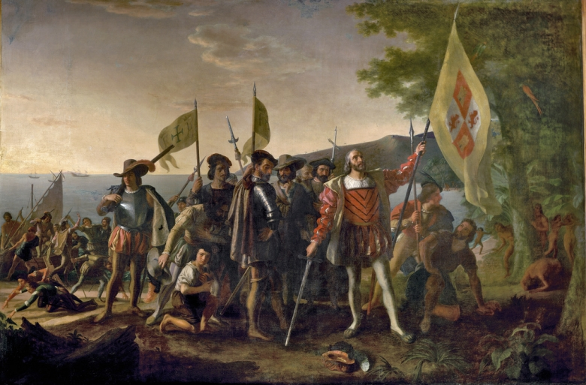
This painting depicts Christopher Columbus and members of his crew on a beach in the West Indies, newly landed from his flagship Santa Maria on October 12, 1492. The island landing was the first landfall of their expedition to find a westward route from Europe to China, Japan and perhaps unknown lands. American neoclassicist painter John Vanderlyn (1775-1852) was commissioned by Congress in June 1836 to paint the Landing of Columbus for the Capitol Rotunda. It was installed in the Rotunda by early January 1847.

