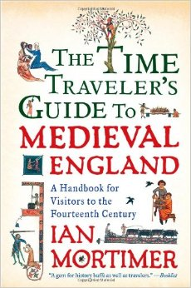
Part II: The Time Traveler’s Guide to Medieval England
The second assignment will give me an idea of your writing style and how well you are able to analyze a secondary text.
​
You will start with by reading the book "The Time Traveler's Guide to Medieval England" by Ian Mortimer. The Rolesville Library does have copies of this book that you can borrow over the summer, HOWEVER, I recommend that you purchase your own copy of the book. That way you can make notes and annotate directly as you read. A copy can be ordered here: http://tinyurl.com/j3hhqte
After reading, you will be writing 3 "mini-essays" based on the questions below. Each essay should be no less than 2 paragraphs, and no more than one page in length. Each topic is covered throughout the book, which is why I recommend taking notes or annotating while you read. Be sure that it is a basic essay format, including a thesis statement (the initial answer to the question) and evidence to support (facts and examples from the book; you should be sure to cite where you found these facts in the book). Keep in mind that you may find support for these answers across several chapters of the book or you may be required to complete outside research to give a complete answer. If this is the case, be sure to cite any outside resources that you may use. For support from within the book, a basic in-text/ parenthetical/ footnote citation will do.

Questions:
- How is life different for the 3 social classes of Medieval England? What advantages and disadvantages do they have?
- What are the main differences between living in a city and a more rural town? Use social, political, and economic examples in your answer.
- How did the following historical events impact life for people in Medieval England?
  - The Peasants Revolt
  - The Black Death
  - Roger Mortimer’s opposition to Edward II

