Warm Up: Period 1 Practice Test Questions
The following four questions refer to the 1572 illustration below of the St. Bartholomew’s Day Massacre
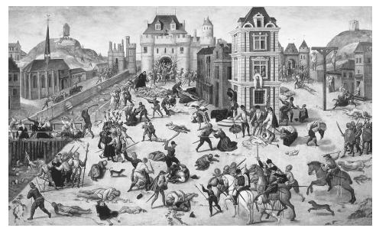

- The above picture depicts which two groups engaged in battle?
- The French Huguenots and Catholics
- Troops of Charles V and the Pope in the sack of Rome
- Peasants and Nobles
- Catholics and Anabaptists
- Which of the following best describes the response to the massacre in Western Europe?
- Spanish surrender to all demands made by France for territory in the New World
- Ended the predominance of the Roman Catholic Church in Italy and France
- Provoked an invasion of France by England and the Netherlands
- Renewed fear among Protestants of Roman Catholic attempts to achieve their total destruction
- The use of propaganda through writing and imagery such as seen above proliferated during the era of religious conflict in European, making which of the following a crucial reason for the success of the Protestant Reformation?
- The widespread use of ballads as a way to share information between towns and villages
- The implementation and proliferation of the printing press
- The political conflict between the Catholic Church and Germanic princes
- The greatly improved travel network of the Holy Roman Empire
- The clash depicted above sparked a greater conflict sometimes characterized by historians as a civil war that was ended by which of the following movements towards religious tolerations?
  - Elizabeth I issued her Elizabethan Settlement allowing private worship
  - Louis XIV issued the Edict of Fontainebleau allowing many Protestants to worship as they pleased in fortified towns
  - Henry of Navarra converted back to Catholicism, became Henry IV of France, and issued the Edict of Nates allowing many Protestants to worship as they pleased
  - The Peace of Westphalia in 1648 allowed Calvinism to be practiced by people in principalities whose leaders choose to follow that religion and its offshoots.

